# Introduction

Analysis is an important phase in SDLC (System Development Life Cycle). It is an essential aspect in project development. It is about determining the user expectations for the project. A system cannot be developed if its requirements are not clear. There has to be a view or concept of what to be included in our system that will benefit the clients, in order to succeed. So these are some of the importance of requirement analysis-

* It helps in breaking a huge problem into micro parts.
* It assists the developers in making decisions.
* It is important to clearly understand what the purpose of a project is.

So, the system requirement analysis have-

* Functional requirement and
* Non-functional requirement

We are going to discuss the analysis methodology for this project. The functional and non-functional requirements of the system. MoSCow prioritization and the diagrammatical explanation of the system functions.

# Analysis Methodology

Some important characteristics of SSADM are:

* Dividing a project into small modules with well-defined objectives
* Useful during requirements specification and system design stage
* Diagrammatic representation and other useful modeling techniques
* Simple and easily understood by clients and developers
* Performing activities in a sequence

Rich picture

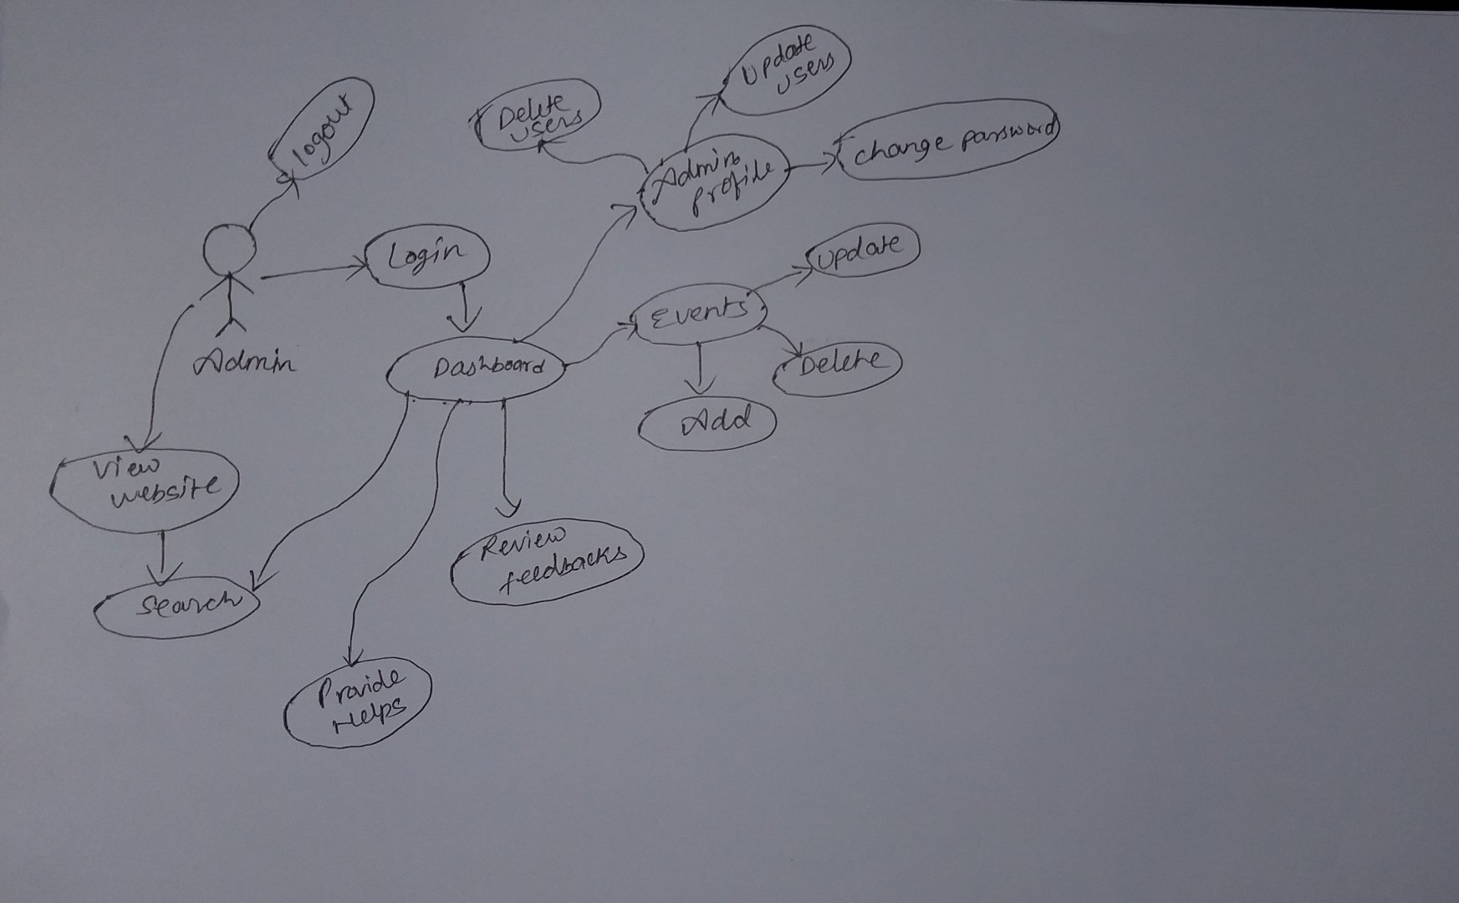

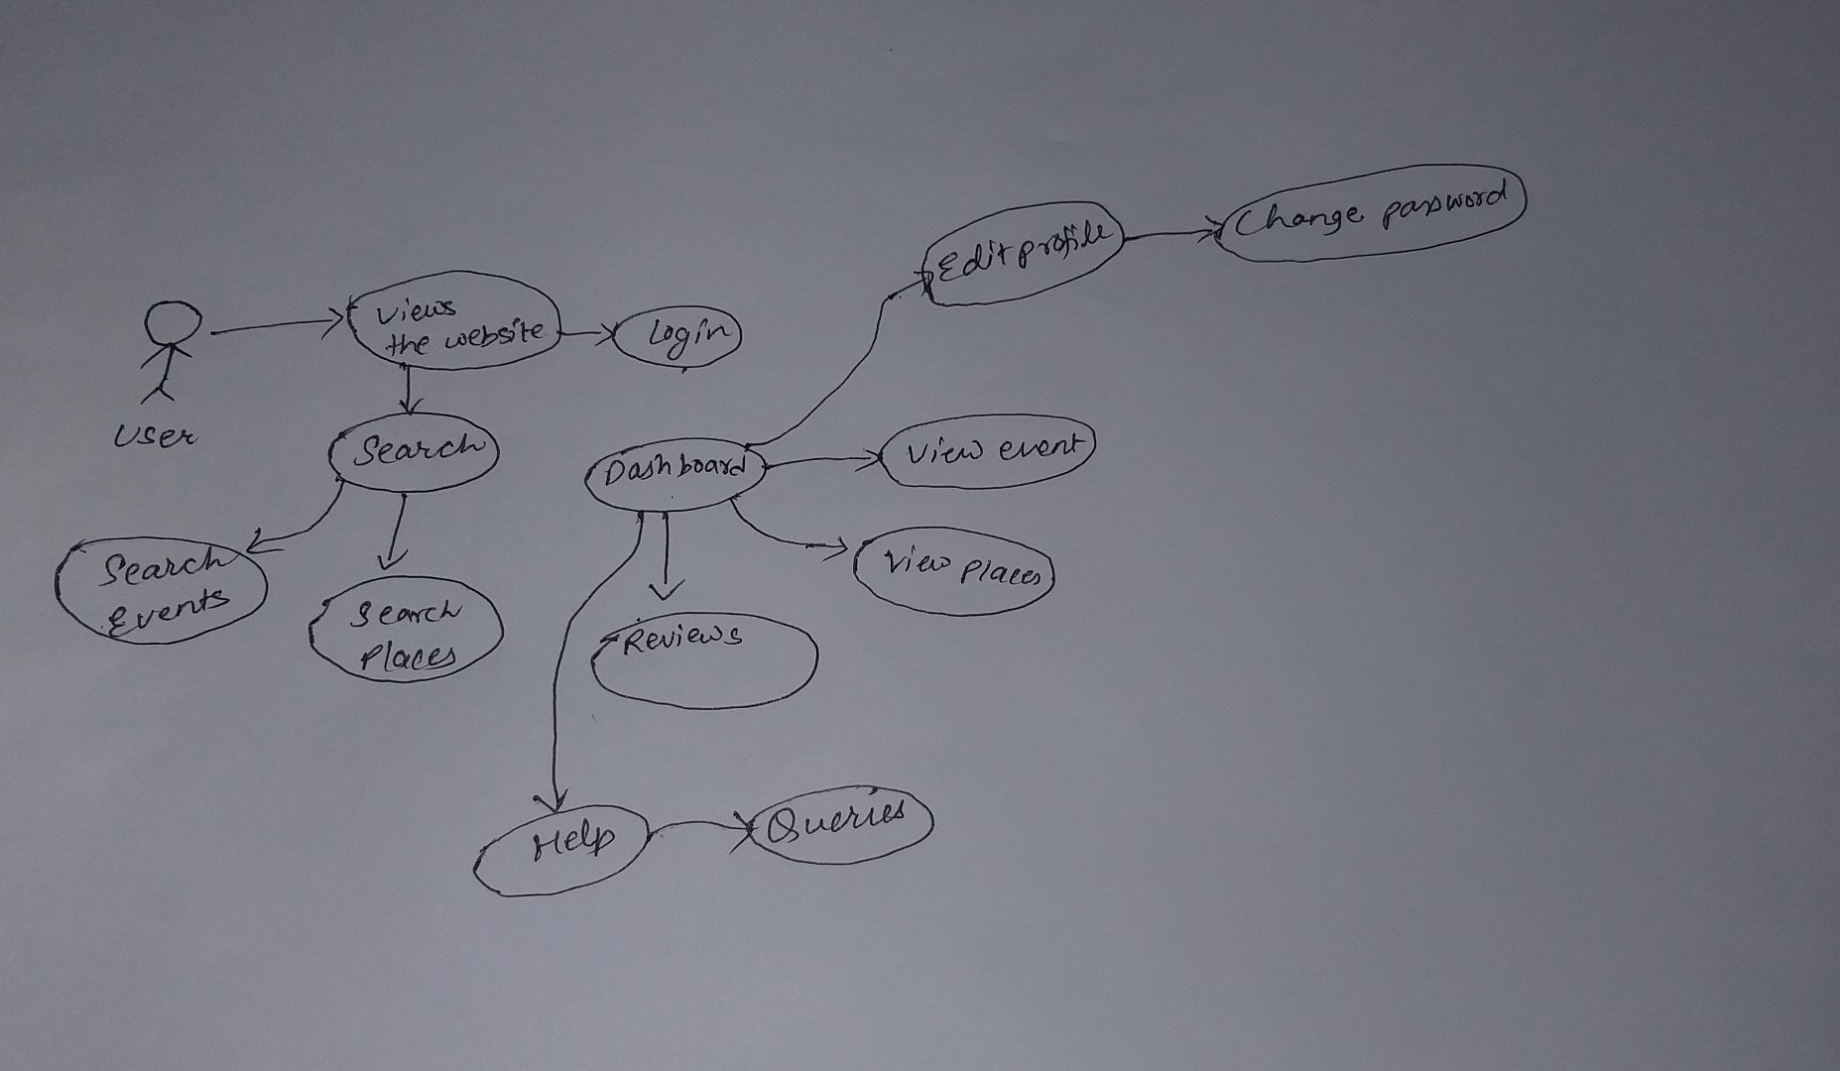

# Feasibility Study

It is an analysis and evaluation of a project if it is feasible on the basis of time, resources, technology, marketing and so on. It helps determine how profitable the project might be or would it be good idea to conduct it or not.

Here we have listed the seven areas of feasibility study-

**Time feasibility**- We are focusing on the amount of time we have, to finish this project. It is the most important one for the success of any project. If it is not completed on time there is no reason for the project to succeed.

**Social feasibility**- We are focusing on the impact this project can have in society. This project doesn’t have any bad impact on the society.

**Operational feasibility**- This focuses on the operational side of the project. Whether it can operate well and take on the new opportunities or not.

**Technological feasibility-** We focus onthe basis of technologythat we have and whether it is enough to work with this project or not.

**Marketing feasibility-** This assessment is all about the stability or the market competency of a project. Whether or not this project has a marketing feasibility or not.

**Resources-** This assessment involves the resources available for the project.

Importance of feasibility study-

* To identify the new opportunities
* Identifies a valid reason to proceed the project
* Helps in identifying the weakness and strength
* Helps in decision-making on the project
* To identify if there are any reason not to proceed

In the table below, we are discussing on the types of feasibility study, the questions answered by it and its relation with the project.

|  |  |  |  |
| --- | --- | --- | --- |
| **S.N** | **Types of feasibility study** | **Questions answered by the study** | **Relation with the project** |
| 1 | Time feasibility | Will the time allocated be enough for this project? | Since, the project is scheduled with Gantt chart and work breakdown structure, it is expected to be finished on time |
| 2 | Social feasibility | What kind of impact does it make on society regarding the cultures? | It helps prevent Nepali culture and tourism development |
| 3 | Operational feasibility | Will the project be able operate well and take on the opportunities? | Being a tourism country, this project is a great opportunity. |
| 4 | Technological feasibility | Will the current technology be enough for creating this project? | I have an internet facility and a reliable device |
| 5 | Marketing feasibility | Will this project have an impact of market? Can it survive? | It is assumed that this project can do very well in market as Nepal is a tourism country and most he the travelers are always seeking for a little help |
| 7 | Resources | Are the resources available for this project enough? | The resources are enough with the fast internet and a reliable device |

# Requirement Analysis

Requirement Analysis, also known as Requirement Engineering, is the process of defining user expectations for a new software to be built. This is a process of determining the requirements and conditions for a new product or project. They define the functionality of the software, which the system to be developed so that the users could easily perform their tasks up to the business requirements. Here, it is sub divided into Functional and non-functional requirement.

**Objectives of Requirement Analysis**

* To introduce the concepts of user and system requirements.
* To describe the system on the basis of functional and non-functional requirements.
* To visualize the idea of the finished product.
* To describe the functionality of the system.

## Functional requirement

They are the product features or functions that must be implemented to enable users to accomplish their tasks. It generally defines the system behavior under certain condition. They are the prioritized requirements for the system.

|  |  |  |  |  |
| --- | --- | --- | --- | --- |
| **ID** | **Title** | **Description** | **Rational** | **Dependencies** |
| FR001 | Create | Creating the user for the system | To make users be able to view the contents | Users have to create an account in order to be able to view the content |
| FR002 | Update function | Updates the viewing contents or users | To update the contents and users | Updating the contents in the website or the user information |
| FR003 | Delete | Deleting the user information | To delete the information | Deleting the user information |
| FR004 | Feedbacks from users | Taking the feedbacks from the user for the functional reviews | To take the audience’s views and thoughts about the content. | It helps to knows the user’s views and the things to be changed or modified |
| FR005 | Map feature | Maps for the different places with their location | To guide the travelers with the location of their destination | It will help people find their destination easily |
| FR006 | Admin login | Login for the admin | To make a system admin account | Makes it easier to view the contents that is only accessible by the admin |
| FR007 | Events details | Details of different kinds of places to visit | To put up the details on ongoing as well as upcoming events | It helps the viewers know what kind of events are going on that might interest them |
| FR008 | Search option | Searching the events or the places | To make it easier for people to search any event, places or activities of their liking | It is a shortcut so that the people do not have to go through the whole list |
| FR009 | Admin dashboard | Dashboard regarding admin details |  |  |
| FR010 | Links of social sites | Social site links for better information | To redirect the users into other social sites | To let them have more information about the project |
| FR011 | Event updates | Updates about different events | To keep the users up-to-date about the events | Helps the travelers keep up with the new and upcoming events |
| FR012 | Database | Keeps the records of events as well as the users | To keep the user and event information | It is an important task as it keeps the record of every data in the project |
| FR013 | Login | Makes user or admin able to login to the system | To let users login to the system to view the coontent |  |
| FR014 | Logout |  |  |  |
|  |  |  |  |  |

+ff

## Non-functional requirement

They are the requirements related to the technical functionality of the system. It describes how the system works.

|  |  |  |  |  |
| --- | --- | --- | --- | --- |
| **ID** | **Title** | **Description** | **Rational** | **Dependencies** |
| NF001 | Responsive website | Is easy to use on any device | To make is responsive on any kind of device | Does not make it hard for the mobile users on tablet users |
| NF002 | User friendly site | Easier to use, not advanced featured | To make is easier for any kind of user |  |
| NF003 | Data integrity | Data integrity facility | Facilitate the users with data integrity |  |
| NF004 | Portability |  |  |  |
| NF005 | Good performance | Does the work it is specified to do | To make is easier for the users to get the information of their needs | Provides the information to the users that they are seeking without any difficulties |
| NF006 | Security function | Data security | Not to leak the information if there are any | It provides security for the user information |
| NF007 | Documentation | Process and stages description | To make the documentation of the project | It helps in keeping the record of the project development so that it can be used in future |
| NF008 | Privacy | User privacy to data | To provide privacy to the user data | It |
| NF009 | Reliability | Reliable stuff for the users |  |  |
| NF010 | Quality | A quality product |  |  |
| NF011 | Responsive time | Response time to users | To response to use requests on time |  |

## MOSCOW prioritization

MoSCoW prioritization, also known as the MoSCoW method or MoSCoW analysis, is a popular prioritization technique for managing requirements. The acronym, MoSCoW, stands for 4 different categories of initiatives: must-haves, should-haves, could-haves, and will not have at this time. Sometimes, the “W” in MoSCoW is used to stand for “wish” instead of “will not have right now.”

Must have

These are the must have functions in the system. The system cannot or may not be able to function without them. They are the must have for the project which needs to be given a quite more amount of time.

Should have

They are the should have functionality of the system that give an additional features.

Could have

Will not have

|  |  |  |
| --- | --- | --- |
| **ID** | **Title** | **MOSCOW** |
| FR001 | Create | Should have |
| FR002 | Update function | Should have |
| FR003 | Delete | Should have |
| FR004 | Feedbacks from users | Should have |
| FR005 | Map feature | Must have |
| FR006 | Admin login | Must have |
| FR007 | Events details | Must have |
| FR008 | Search option | Should have |
| FR009 | Admin dashboard | Must have |
| FR010 | Links of social sites | Should have |
| FR011 | Event updates | Should have |
| FR012 | Database | Must have |
|  |  |  |

## SRS (System Requirement Specification)

Pre SRS

|  |  |
| --- | --- |
| **Hardware Requirements** | **Software Requirements** |
| 1 GB RAM | Operating system- Windows 10 |
|  | Database- mySQL |
|  |  |
|  |  |

Post SRS

|  |  |
| --- | --- |
| **Hardware Requirements** | **Software Requirements** |
| Minimum 1 GB RAM |  |
|  |  |
|  |  |
|  |  |
|  |  |

# Use case diagram

1. Admin login

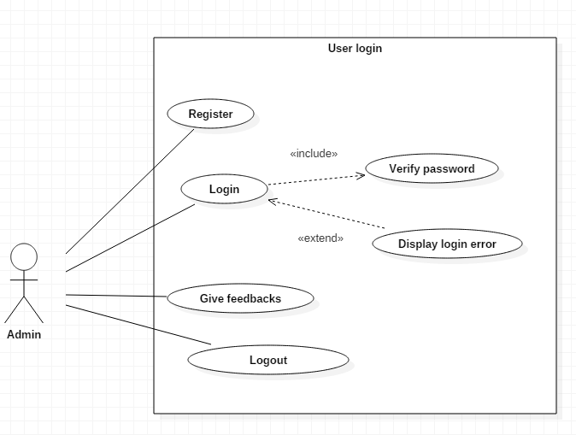

1. User login

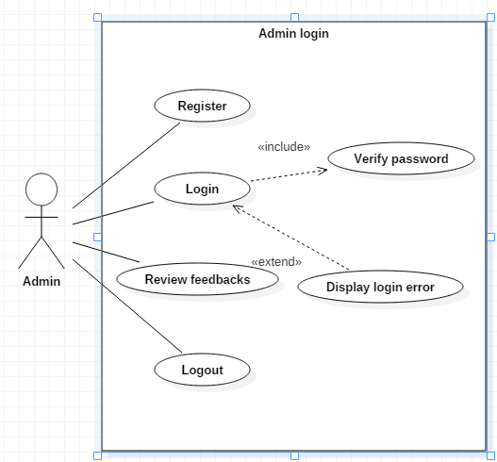

1. Event view use-case

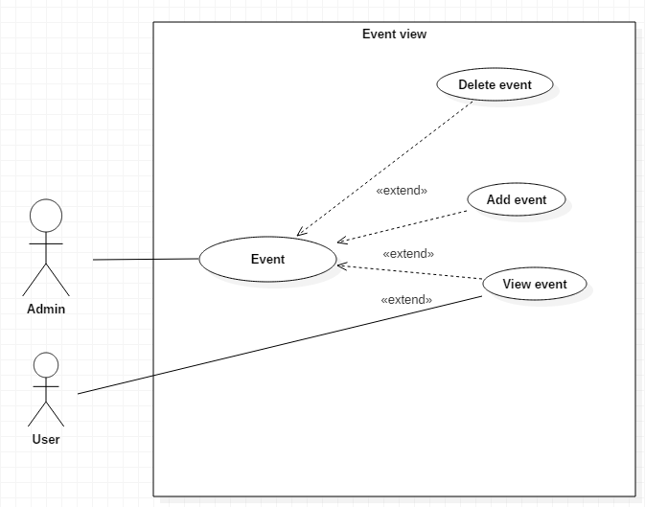

# NLA and Initial class diagram